Name:

Forecasting the Weather Worksheet

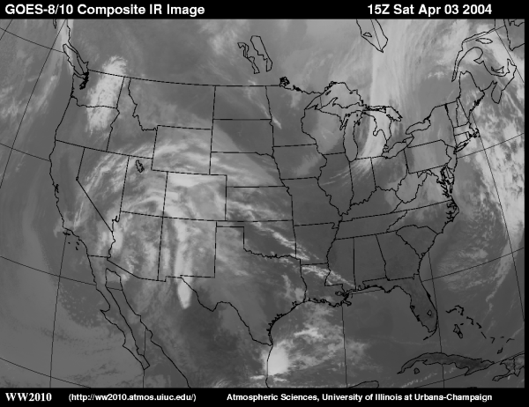

Introduction: How do meteorologists forecast the weather? In this web quest we will explore air masses, fronts, weather stations and weather forecasts.

Procedure: Follow the links for each question and write down your responses on the Forecasting the Weather Worksheet.

1. What is an air mass?

2. Describe the temperature, moisture and air pressure associated with a Continental Polar air mass.

3. Describe the temperature, moisture and air pressure associated with a Maritime Tropical air mass.
4. Describe a high pressure center. What is another name for a center of high pressure?

5. What is a cyclone? What direction do winds flow in cyclones in the Northern Hemisphere? In the Southern Hemisphere?

6. Watch this animation on how winds flow around cyclones (pressure lows) and anticyclones (pressure highs) in the Northern Hemisphere. Describe what you observe below.

7. What is the definition of a front?

8. What is a cold front? How do conditions compare before, during, and after a cold front moves through.

9. Watch the animation of a cold front and describe the type of precipitation associated with cold front movement.

10. What is a warm front How do conditions compare before, during, and after a warm front moves through.

11. Watch the animation of a warm front and describe the type of precipitation associated with a warm front.

12. What is a Supercell Storm? What dangerous conditions may develop during supercell storms? What wind and cloud conditions are prevalent in supercell storms?

13. What is the “Jet Stream” and at what altitude is the jet stream measured?

14. a. Describe the “trends” method of forecasting. What factors does a meteorologist using the trends method consider?

b. If a line of thunderstorms is located 60 miles to your northwest and moving southeast at 30 miles per hour, how long will it take to reach your location? Show your calculation.

15. What altitude do high level clouds form at?

What are the names of the high level clouds?

What altitude do mid level clouds form at?

What are the names of the mid level clouds?

What altitude do low level clouds form at?

What are the names of the low level clouds?

16. Hurricanes are formed from thunderstorms. What 3 criteria must
be met for a hurricane to develop from a thunderstorm?

